The SQL queries aim to analyze historical flood data, determine areas with high flood risk, generate early warning alerts, retrieve preventive measures, retrieve emergency response plans, and identify evacuation centers based on location.

**-- Analyzing Historical Flood Data**

**SELECT l.Region AS Location, AVG(fd.Magnitude) AS AverageMagnitude**

**FROM Location l**

**JOIN FloodData fd ON l.LocationID = fd.LocationID**

**GROUP BY l.Region;**

**-- Determining Areas with High Flood Risk**

**SELECT l.Region AS Location, AVG(fd.Magnitude) AS AverageMagnitude**

**FROM Location l**

**JOIN FloodData fd ON l.LocationID = fd.LocationID**

**GROUP BY l.Region**

**HAVING AVG(fd.Magnitude) > 4;**

**-- Generating Early Warning Alerts**

**SELECT l.Region AS Location, ewa.\***

**FROM Location l**

**JOIN EarlyWarningAlert ewa ON l.LocationID = ewa.LocationID**

**WHERE l.LocationID = 1; -- Example: LocationID 1**

**-- Retrieving Preventive Measures**

**SELECT l.Region AS Location, pm.\***

**FROM Location l**

**JOIN PreventiveMeasure pm ON l.LocationID = pm.LocationID**

**WHERE l.LocationID = 1; -- Example: LocationID 1**

**-- Retrieving Emergency Response Plans**

**SELECT l.Region AS Location, er.\***

**FROM Location l**

**JOIN EmergencyResponse er ON l.LocationID = er.LocationID**

**WHERE l.LocationID = 1; -- Example: LocationID 1**

**-- Identifying Evacuation Centers**

**SELECT l.Region AS Location, ec.\***

**FROM Location l**

**JOIN EvacuationCenter ec ON l.LocationID = ec.LocationID**

**WHERE l.LocationID = 1; -- Example: LocationID 1**

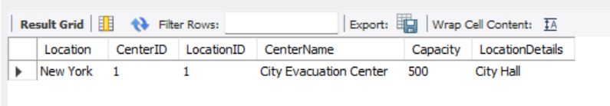

**40)** **Query to Retrieve Historical Flood Data:**

**SELECT * FROM FloodData;**

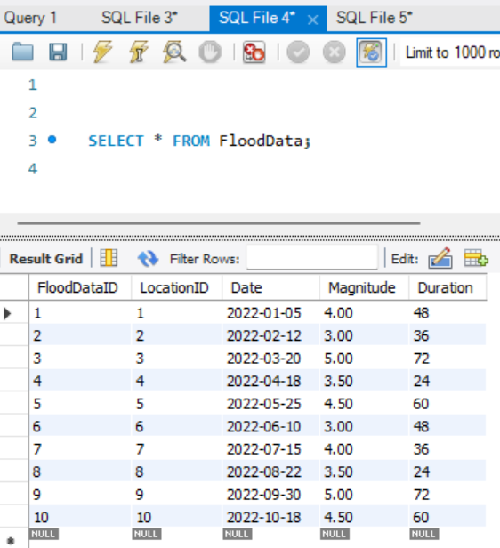

FINAL RESULT OF THIS PROJECT:

-- 1. Analyzing Historical Flood Data for All Cities

SELECT fd.*, l.Region AS Location

FROM FloodData fd

JOIN Location l ON fd.LocationID = l.LocationID;

-- 2. Average Magnitude of Floods in Each Region

SELECT l.Region AS Location, AVG(fd.Magnitude) AS AverageMagnitude

FROM Location l

JOIN FloodData fd ON l.LocationID = fd.LocationID

GROUP BY l.Region;

-- 3. Early Warning Alerts for All Cities

SELECT ewa.*, l.Region AS Location

FROM EarlyWarningAlert ewa

JOIN Location l ON ewa.LocationID = l.LocationID;

-- 4. Preventive Measures for All Cities

SELECT pm.*, l.Region AS Location

FROM PreventiveMeasure pm

JOIN Location l ON pm.LocationID = l.LocationID;

-- 5. Emergency Response Plans for All Cities

SELECT er.*, l.Region AS Location

FROM EmergencyResponse er

JOIN Location l ON er.LocationID = l.LocationID;

-- 6. Evacuation Centers for All Cities

SELECT ec.*, l.Region AS Location

FROM EvacuationCenter ec

JOIN Location l ON ec.LocationID = l.LocationID;

-- 7. Query 7 Description

SELECT * FROM YourTableName WHERE YourCondition;

-- 8. Retrieve Emergency Response Logs for All Cities

SELECT erl.*, l.Region AS Location

FROM EmergencyResponseLog erl

JOIN Location l ON erl.LocationID = l.LocationID;

-- 9. Retrieve Authorities for All Cities

SELECT a.*, l.Region AS Location

FROM Authority a

JOIN Location l ON a.LocationID = l.LocationID;

-- 10. Flood Data for All Cities

SELECT fd.*, l.Region AS Location

FROM FloodData fd

JOIN Location l ON fd.LocationID = l.LocationID;

OUTPUT:

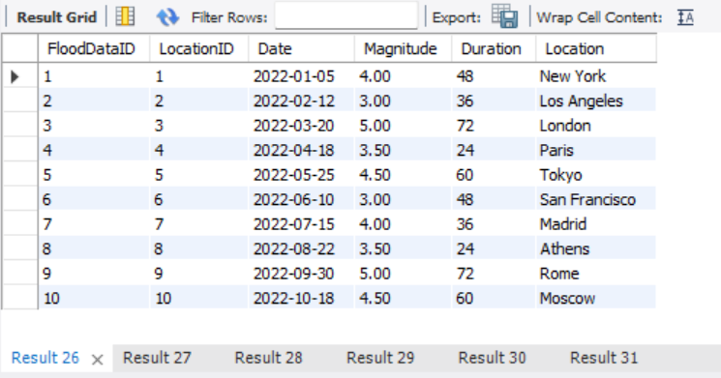

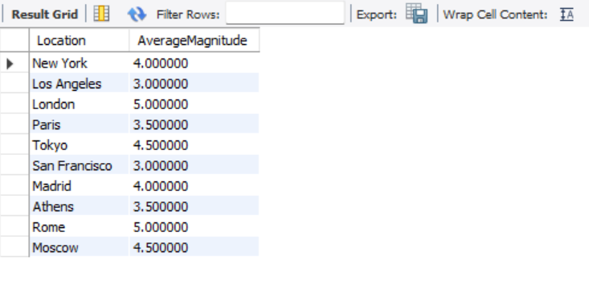

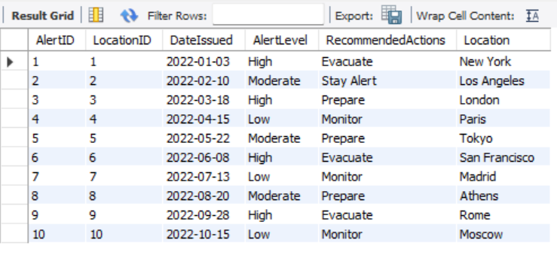

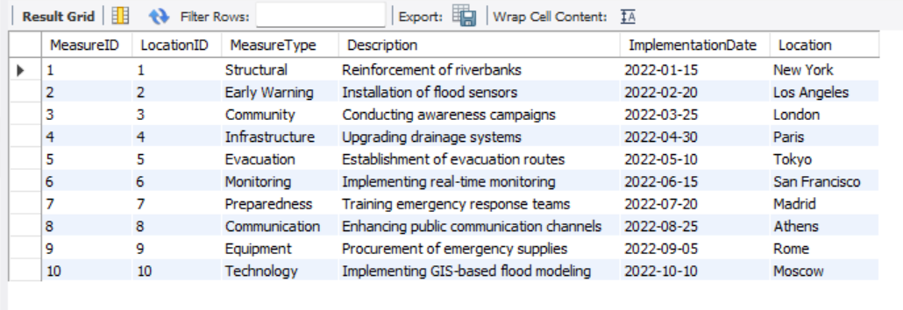

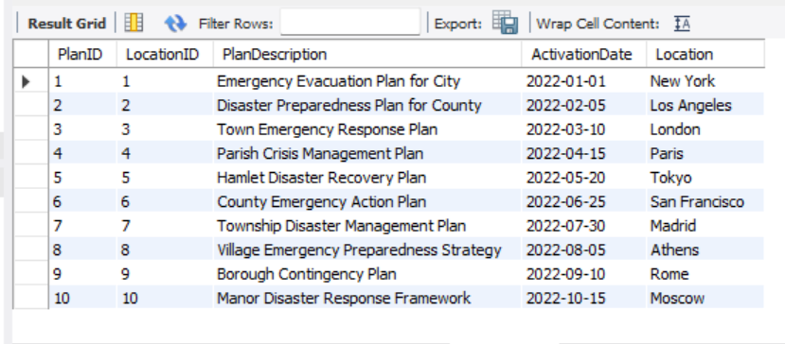

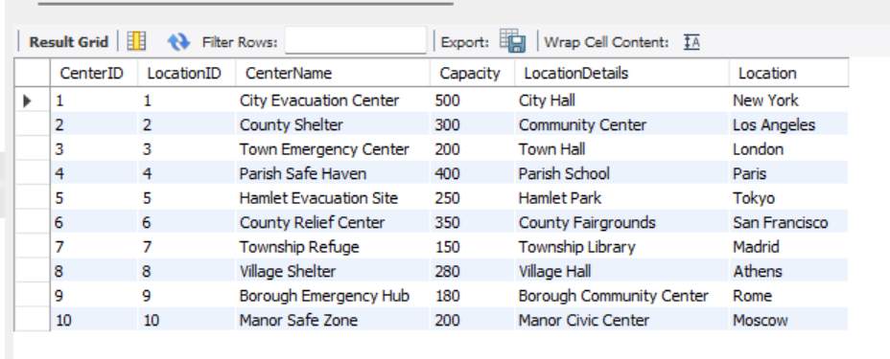

**RESULT:**

Thus, working with queries related to project on MySQL is successfully verified.

**SAMPLE FRONTEND:**

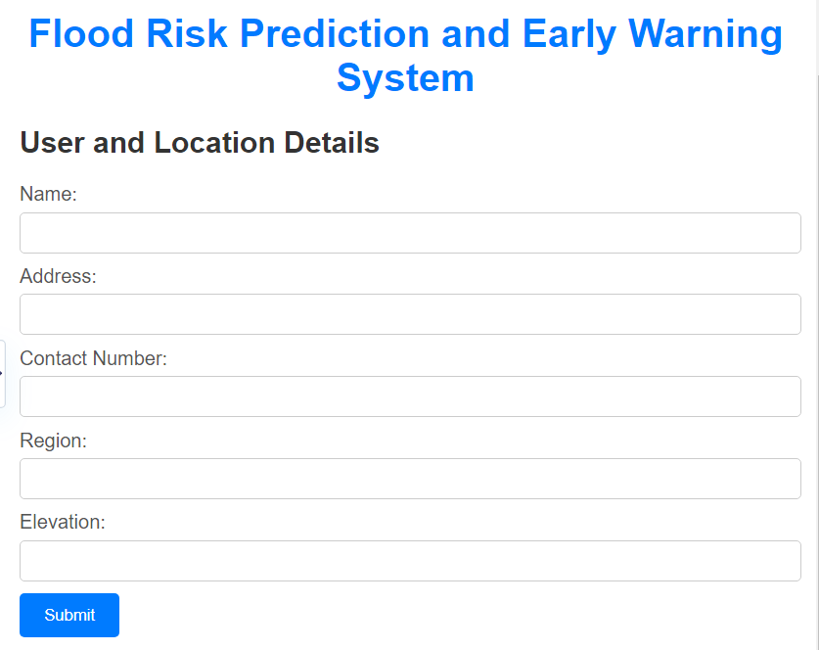

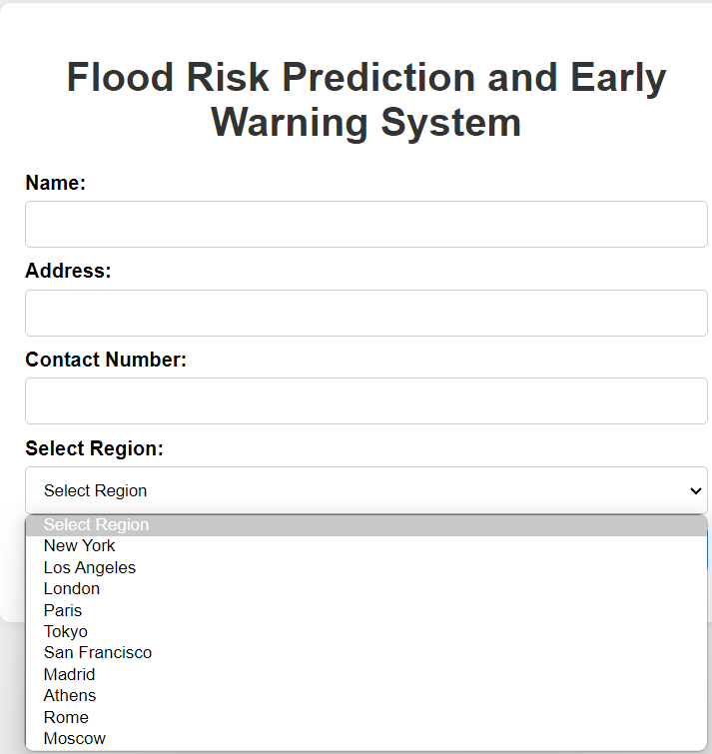

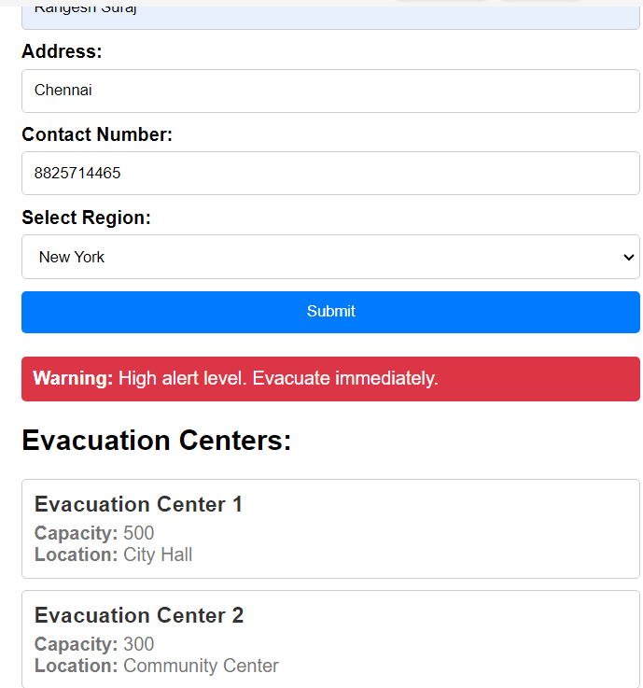

* The user fills out the form with their details and selects the region from the dropdown.
* Upon submission, the system fetches the alert details based on the selected region.
* If the alert level is "High," a warning message is displayed along with the recommended actions.
* Evacuation centers are displayed below the warning message, providing users with information on where to evacuate in case of a high alert level.
* The design is clean and user-friendly, with proper alignment and color scheme to enhance readability and usability.